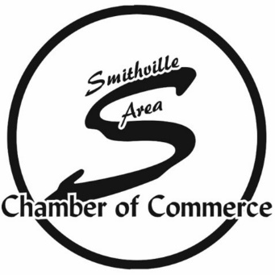
Smithville Chamber of Commerce
Membership Meeting Minutes
January 11th, 2023
Smithville American Legion Post 58
Sponsored by Smithville American Legion Post 58
Meeting called to order by Scott Pearson at 11:58am.
The invocation given by Pastor Rob Ernest was followed with the Pledge of Allegiance.

- The Board of Directors were sworn in by Erika.
- Scott Pearson passed on Presidential duties to Rebecca Pendleton-Meek.
- Scott Pearson was given a gift by the Board in recognition for all his years served to the Chamber Board.
- The board members that served with Scott in the last year sent Scott off with remembrances and thanks for all he has done.

Meeting Minutes
The December 2022 minutes were presented for approval. Harley Morlock moved that the minutes be approved as presented, Phil Zehms seconded the motion. The motion passed.
Treasurer’s Report
The December 2022 treasurer’s report was presented for approval by Treasurer Karen Lane. Leo Slenker moved that the treasurer’s report be approved as presented, Don Hanks seconded the motion. The motion passed.
Member Introductions
Chamber members introduced themselves and the business or organization they represent. All guests in attendance were also introduced and welcomed.

Program: Smithville American Legion 58
- Hope Hallowell introduced Bill Gagnon who is the Director of the Riders Group for the American Legion. He spoke about the riders and how it is formed. He spoke about the importance of the riders and what they do to help different Veterans in different communities. He spoke about the importance of the Legacy Ride and what it helps to support.

REPORTS:
Executive Director Report – Erika Winston
- New Members this month are Garland Chapter #287 Order of the Eastern Star, Not Too Shabby Boutique, Wild Bloom Art Company, Backwoods Venue 222, Dream Homes by Jen, Metropolitan Community College Maple Woods, Ellen Crow, Isotech, Inc./KCCoyote, Inc.
- Erika announced our next event is the Crawfish Boil on February 21st and tickets are $20.00.
- Smithville Community Awards Banquet will be held February 23rd and ticket can be bought until February 1st.
- Erika announced that we will be taking nominations for people in the community until January 23rd. She announced all the categories that you can nominate people for and how they can be nominated.
- Erika announced there is still time for sponsorship, but that will be coming to a close soon.
- The banquet will be held at White Iron Ridge.

City of Smithville Report – Cynthia Wagner
- She spoke about some new city projects coming up.
- She stated that the waterline replacement is almost finished.
- The Public Water Department is looking at new projects for the next 2-3 years and working with the cities engineers that developing plans for these projects. They will be working on getting bids ready for these projects.
- Cynthia introduced Alex Threlkeld our new Parks and Recreation Manager and Aspen Ryan who is the new Recreational Programmer for Smithville. They have been working on putting together several new programs and recreational opportunities throughout the community.
- Cynthia announced some new events coming up they are working on. The Easter Egg Hunt with the Chamber, a new Dodge Ball Corporate Challenge, and a Mother Daughter Tea.
- Cynthia did announce the upcoming Alderman Board meeting and that they will be discussing what will be on the April Ballot for vote.

Smithville Public Schools Report – Robert Hedgecorth
- Robert spoke about what is going to be on the April ballot for the Smithville School District.

Old Business:
There is none currently.

New Business:
There is none currently.

Special Drawings:
There was no drawing.

Special Announcements
Special announcements were made by Chamber members advertising future events and activities in the Smithville community.
There being no further business, the meeting was adjourned at 12:58pm

